Multilayer Perceptron and how to apply it using Tensorflow/ Keras library.

Dataset generation

Use following code to generate the training and the testing dataset. This dataset is similar to XOR but have 3 classes. X_train and y_train are features and labels for the training dataset. Similarly, X_test and y_test are features and labels for the testing dataset.

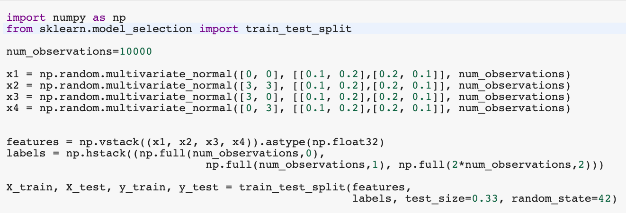

Task 1 – Visualize the complete dataset where samples belong to one class have same color. Show the legend and axes name as well.

Task 2 – Train a neural network with 2 hidden layers. Keep both hidden layers as dense (fully connected) layer. Train it on 5 different settings.

|  |  |  |  |
| --- | --- | --- | --- |
| Settings | Nodes in first hidden layer | Nodes in second hidden layer | Dropout |
| 1st | 10 | 10 | 0.1 |
| 2nd | 20 | 30 | 0.1 |
| 3rd | 50 | 50 | 0.8 |
| 4th | 50 | 50 | 0.1 |
| 5th | 100 | 100 | 0.5 |

Task 3 – For each setting, plot the decision boundary.

Task 4 – Show the training and testing results for each setting and also analyze the effect of changing the hidden layers and dropout on decision boundary’s.

Hint:- Go through the following link to understand how to use Keras in TensorFlow environment. Keep the

model.compile, model.fit and model.evaluate as it is.

https://www.tensorflow.org/tutorials/quickstart/beginner